My portfolio

Code:

<!DOCTYPE html>

<html lang="en">

<head>

    <meta charset="UTF-8">

    <meta name="viewport" content="width=device-width, initial-scale=1.0">

    <title>My Portfolio</title>

    <link href="https://fonts.googleapis.com/css2?family=Pacifico&display=swap" rel="stylesheet"> <!-- Adding a peculiar font -->

    <style>

        /* General body styles */

        body {

            font-family: 'Pacifico', cursive; /* Peculiar font */

            background: linear-gradient(to right, #e3d8ff, #f0e6ff); /* Lavender to Violet gradient */

            color: #4a4a4a;

            margin: 0;

            padding: 0;

            line-height: 1.6;

        }

        header {

            background-color: #6a4c93; /* Violet color */

            color: white;

            padding: 20px;

            text-align: center;

            border-radius: 10px; /* Round corners */

            box-shadow: 0 4px 6px rgba(0, 0, 0, 0.1);

        }

        header h1 {

            margin: 0;

        }

        section {

            padding: 20px;

            margin: 20px auto;

            background-color: #ffffff;

            border-radius: 15px; /* Round corners */

            box-shadow: 0 4px 10px rgba(0, 0, 0, 0.1);

            max-width: 900px;

        }

        section h2 {

            color: #6a4c93; /* Violet color */

            font-size: 24px;

            border-bottom: 2px solid #6a4c93;

            padding-bottom: 10px;

        }

        ul {

            list-style-type: square; /* Bulleted list with square bullets */

            padding-left: 20px;

        }

        li {

            margin: 10px 0;

        }

        a {

            color: #6a4c93; /* Violet color */

            text-decoration: none;

        }

        a:hover {

            text-decoration: underline;

        }

        #contact a {

            display: inline-block;

            margin-right: 10px;

        }

        /* Hover effect for sections */

        section:hover {

            background-color: #f1f1f1;

            box-shadow: 0 6px 12px rgba(0, 0, 0, 0.15);

        }

    </style>

</head>

<body>

    <header>

        <h1>My Portfolio</h1>

    </header>

    <section id="introduction">

        <h2>Self Introduction</h2>

        <p>Hello! I am Sm, a passionate B.Tech student with a keen interest in technology and software development. Welcome to my portfolio!</p>

    </section>

    <section id="skills">

        <h2>Skills</h2>

        <ul>

            <li>Web Development</li>

            <li>Programming (C, C++, Python)</li>

            <li>Database Management</li>

        </ul>

    </section>

    <section id="projects">

        <h2>Projects & Work Experience</h2>

        <ul>

            <li><a href="https://github.com/sm/project1" target="_blank">Project 1</a></li>

            <li><a href="https://github.com/sm/project2" target="_blank">Project 2</a></li>

        </ul>

    </section>

    <section id="feedback">

        <h2>Feedback & Achievements</h2>

        <ul>

            <li>Received positive feedback for my contributions to open-source projects.</li>

            <li>Participated in and won several college-level coding competitions.</li>

        </ul>

    </section>

    <section id="education">

        <h2>Education Profile</h2>

        <p>Bachelor of Technology (B.Tech) - Keshav memorial Institute Of Technology - 3rd year</p>

    </section>

    <section id="contact">

        <h2>Contact Information</h2>

        <ul>

            <li>Email: <a href="mailto:sm@gmail.com">sm@example.com</a></li>

            <li>Phone: +1234567890</li>

            <li>Social Media:

                <a href="https://linkedin.com/in/sm" target="_blank">LinkedIn</a> |

                <a href="https://twitter.com/sm" target="_blank">Twitter</a>

            </li>

        </ul>

    </section>

</body>

</html>

Output:

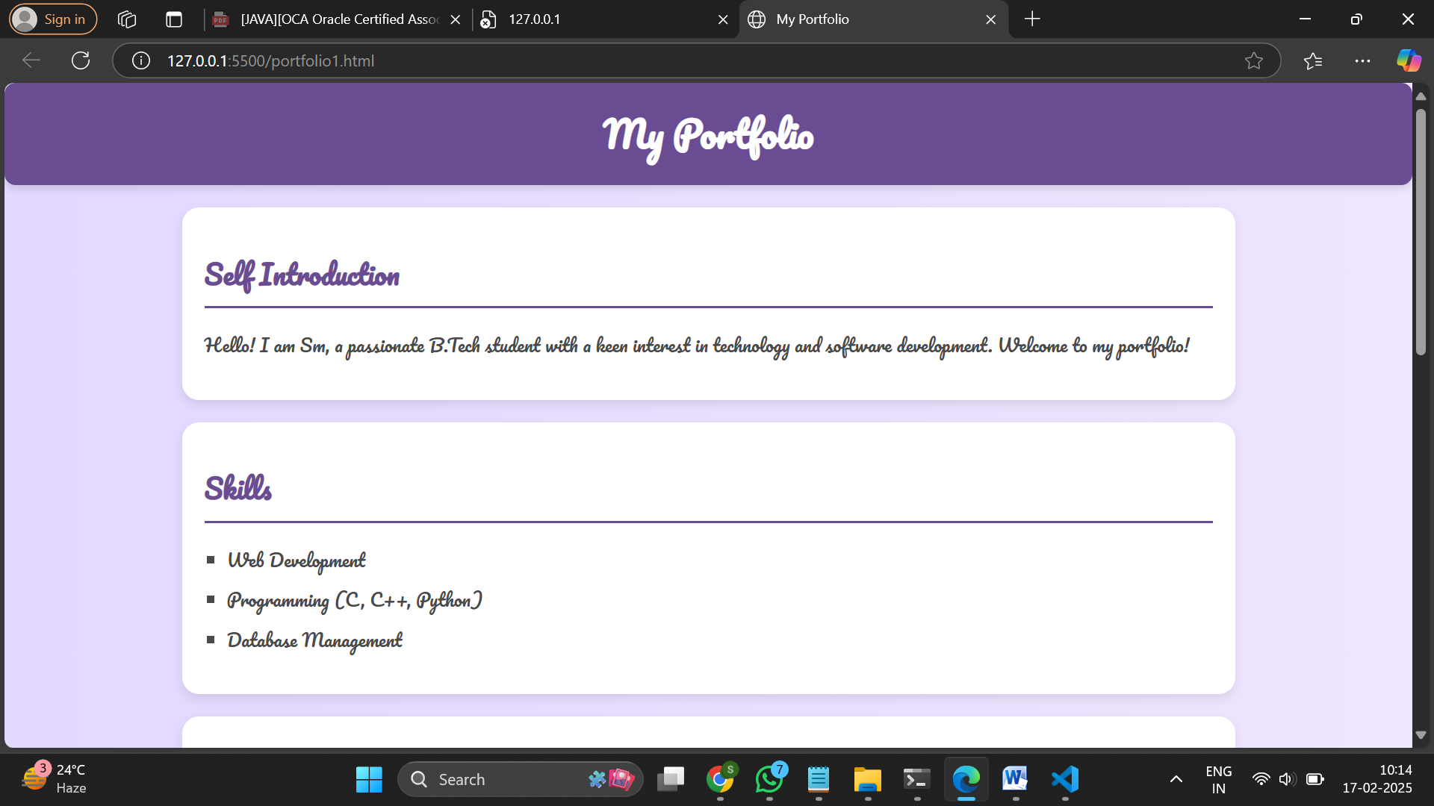

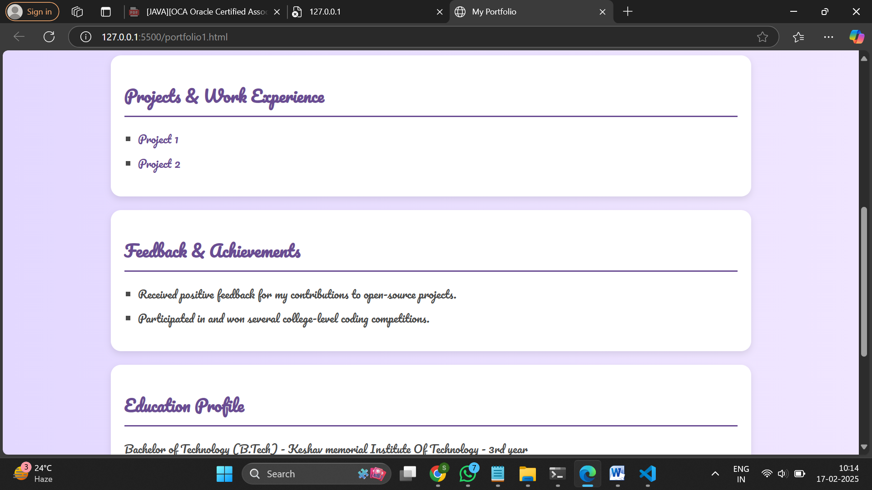

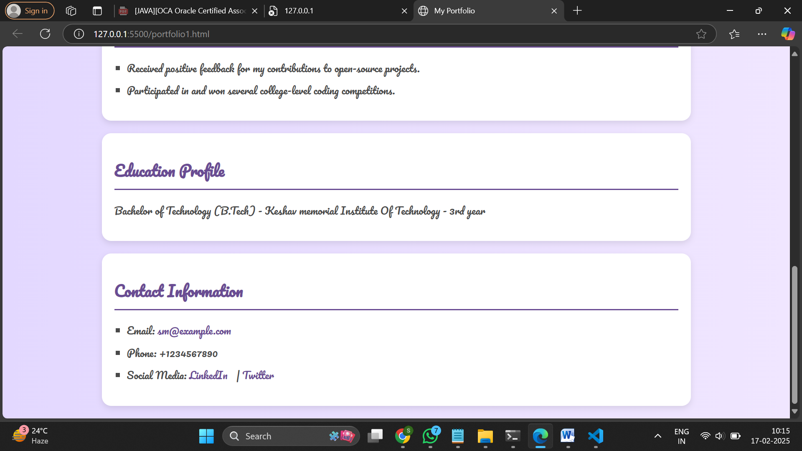

Githublink: https://github.com/AjeersMyna/FEWD_LAB.git

SandboxLINK: https://456qlx.csb.app/